/\* Ashok R

SSRS Introduction Lab work

6.1.19

\*/

/\*1. Do the class room assignment 3 times. (Only show screen shots for one round)

2. Create a DataSet using 4 tables in a join.

4. Create 5 different Objects/Report using the dataset.

5. Take a screenshot of each individual report with an explanation of what the chart is showing

below the chart.

6. Review your SSRS Dashboard Project

Find an article that explains the importance of Reporting in an organization. Write a one paragraph

summary on the article and post it to the Class Discussions. Take a screenshot and include it with this

assignment. \*/

1……..

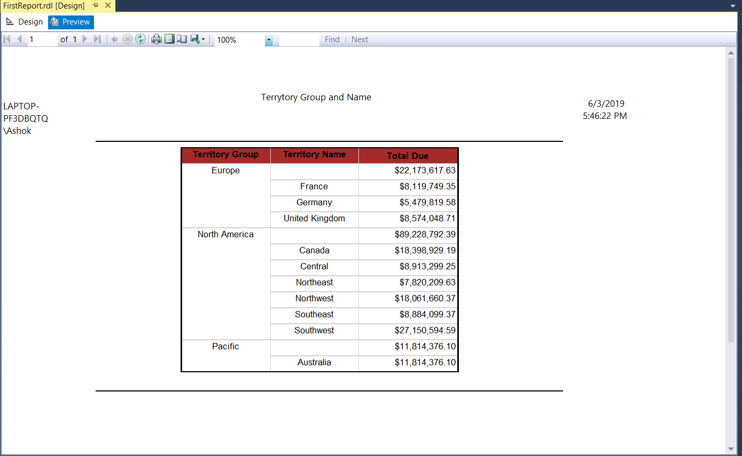

This report shows the Territory Group, Territory Names with respective group and their Total Due. Here we can see Total Due for whole Territory Group level and also for individual Territory Name. Report also shows Header details as User, Title of Report and execution time.

2…. Design Sales Rep and Total Due

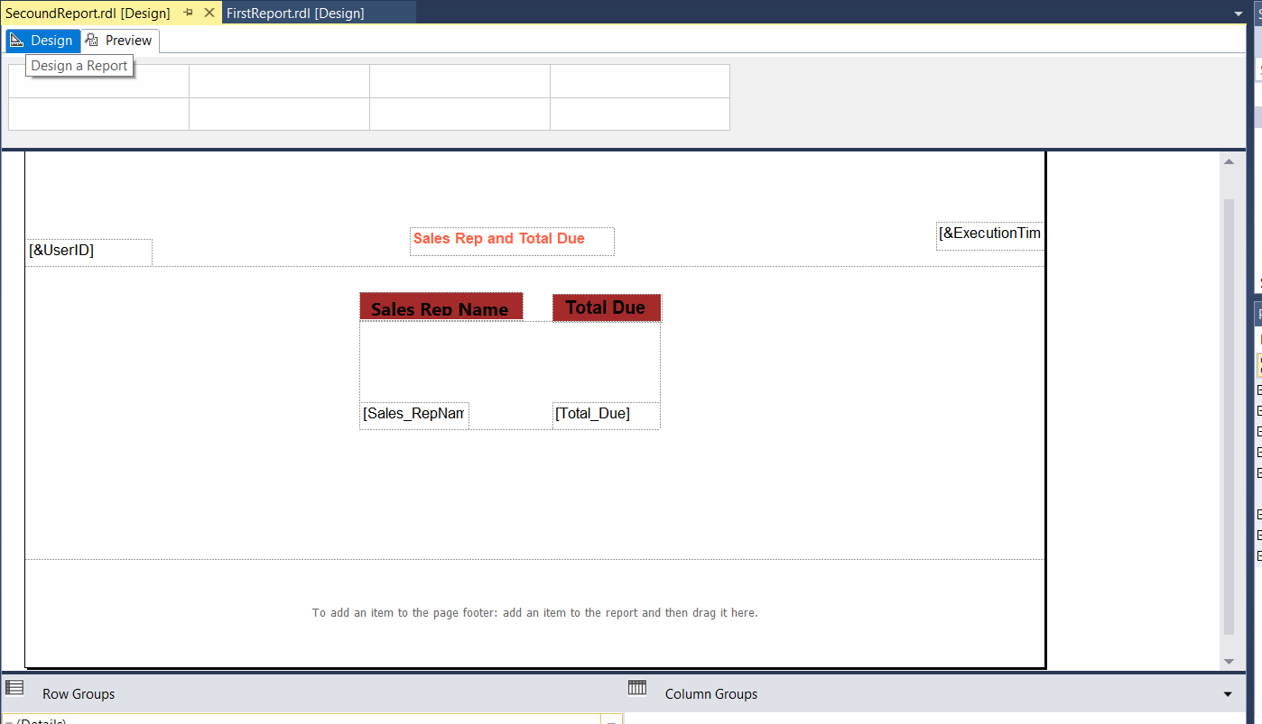

Preview of Above design

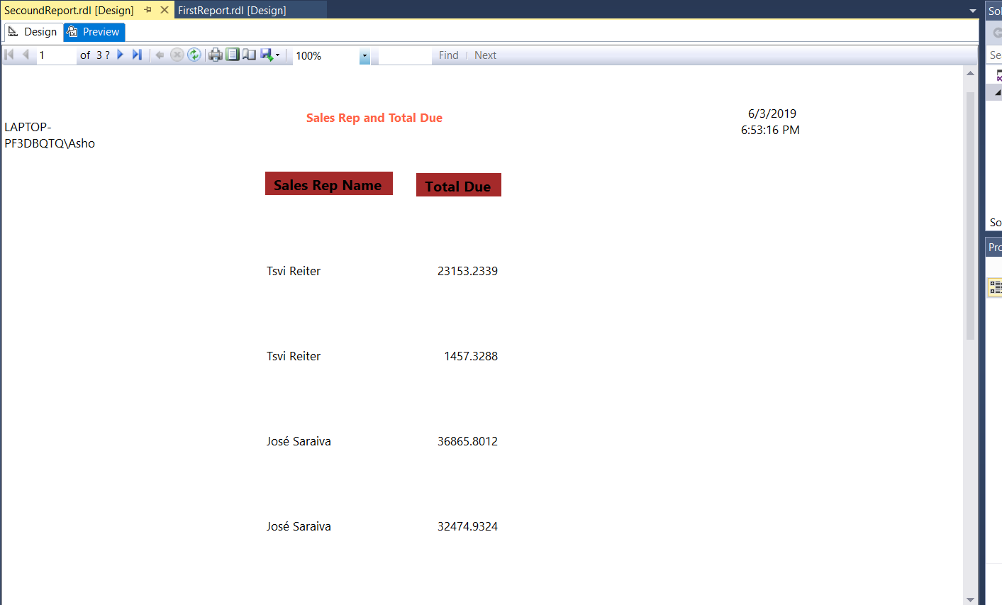

Here I have shown Sales representative list in Rectangle with their total dues.

Report has its header for Page name, user name with execution timestamp.

Report doesn’t contain any grouping for Sales rep’s total due.

3… Image and SubReport with toggle button on Textbox

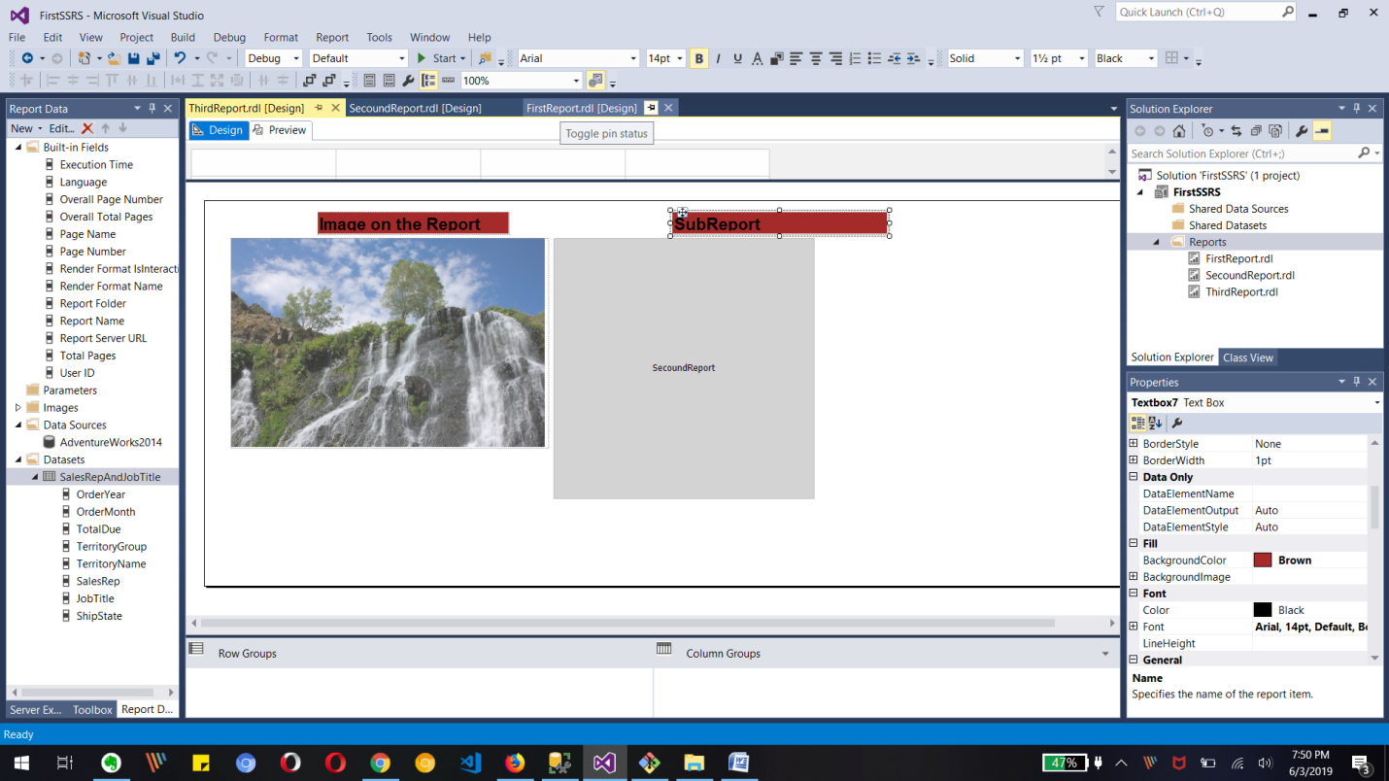

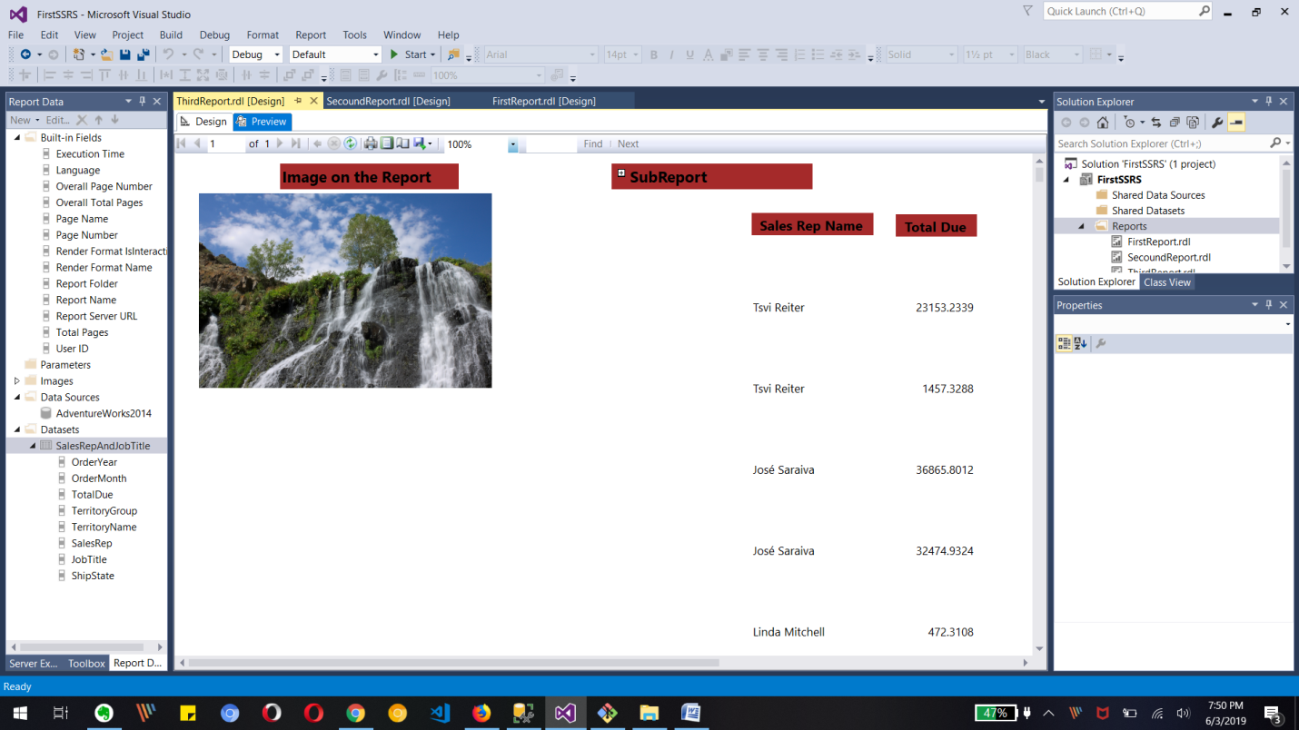

There report shows Image with its text box and Sub Report tag with toggle button on its text box/sub report header. The sub report will be hide/shown based on click and the report contains sales rep and their total due amount.

4… Territory Name with order year and month with their Total Due

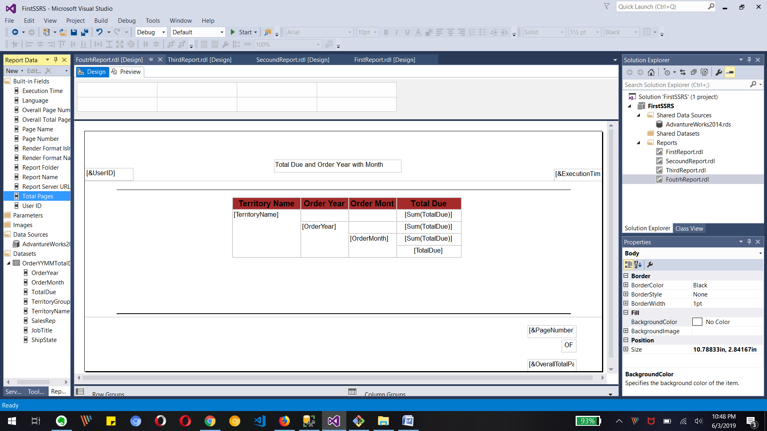

Preview

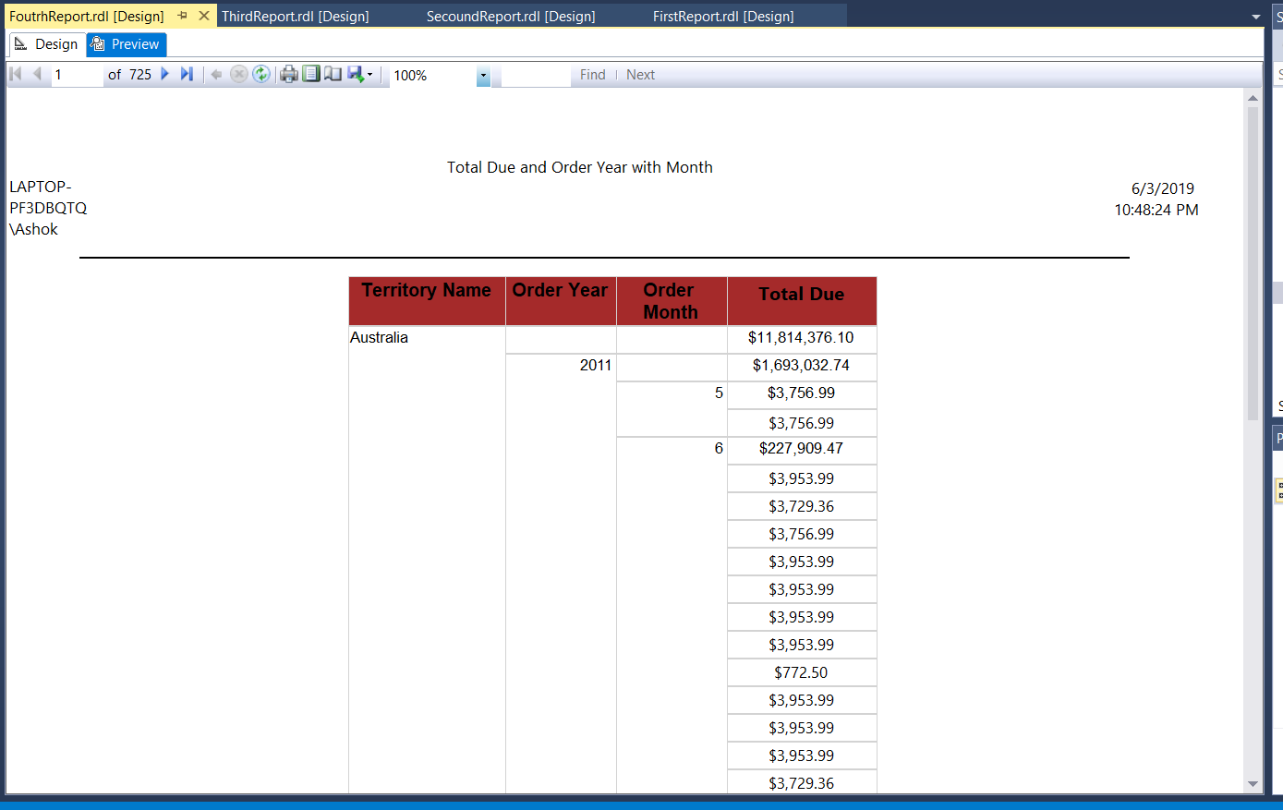

The above report shows Territory Name and Order year, Month with their respective Total Due.

Report contains each level of Total Due like for Territory Name, by Year or by Month for specific territory. I have also added page number and total pages in report has.

5….